|  |  |
| --- | --- |
| 5 Long-Term Benefits of Resistance Training  Workout fundamentals  An initial look into resistance training |  |

Mark Ashinhust

Hello!

Welcome to my training program containing all the knowledge and experience I have learned from colleagues and information I’ve read throughout the past few years. The experience I have gained at the gym and within my life has been eye opening and I hope that I can share this with you.

Getting started at the gym and finding a good workout routine is an issue that many of us constantly face. In a utopian society we would only have to do this once. We go to the gym, start eating better foods, feel great and never stop! Sadly, this is not the case.

Whether you just had a long bender for a weekend or a for a few weeks and decide you need to get in shape or just took a good look in the mirror, I am glad that you are motivated! However, what we need to do is take that motivation and turn it into discipline. As author Sal Di Stefano states in his book *The Resistance Training Revolution*, the main issue people have with going to the gym and continuing at the new year is their commitment to motivation rather than discipline. Getting started going to the gym is a great thing but you need to start out slowly and methodically, otherwise it will be too difficult to keep up with in the long run.

That is exactly what I am trying to do here today! Below you will find small but simple training plans to develop fundamental resistance training forms and strength. Whether you are interested in going to the gym 3, 4 or 5 days a week or working out 15 minutes at home, you are already at a great start! There are so many benefits from being active with your body 15 minutes a day. Keep your head up and let‘s get moving!

VOCABULARY

* These words are going to come up frequently throughout this program. Some are new terminology while others are just abbreviations.

RPE – Rate of Perceived Exertion

This is your judgement of how you feel once you have completed an exercise. A 10 means there was no possible way you could have completed another set. Most exercises should be around an 8 unless you are an experienced lifter.

LSRPE – Last Set RPE (Rate of Perceived Exertion)

The same as above, however, this only applies to your last working set.

DB – Dumbbell

Abbreviation for the weight

EVOO – Extra Virgin Olive Oil

YOUR MUSCLES

ARMS

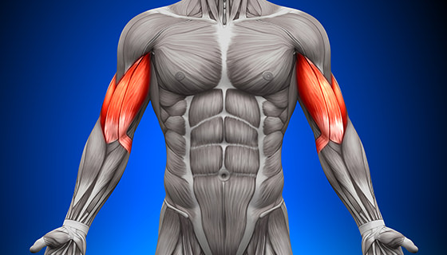Bicep: This is a two headed muscle containing a long and a short head. They both flex the elbows out and in and supinate the wrist (twists the palm face down and up). The other name for these muscles is the biceps brachii.



Triceps: These are one of the largest and used muscles. The triceps are located on the back of your upper arm and have three heads. The long, medial and lateral head. These muscles are what allows you to extend your elbow and come with a lot of useful exercises.

Deltoids: Also known as delts, there muscles are comprised of three different heads. The front (anterior), lateral (middle delt *not medial) and the posterior (rear). These act to flex the shoulder, abduct the upper arm and abduct the shoulder, respectively. This is what allows us to work on the shoulders in many exercises below.

LEGS

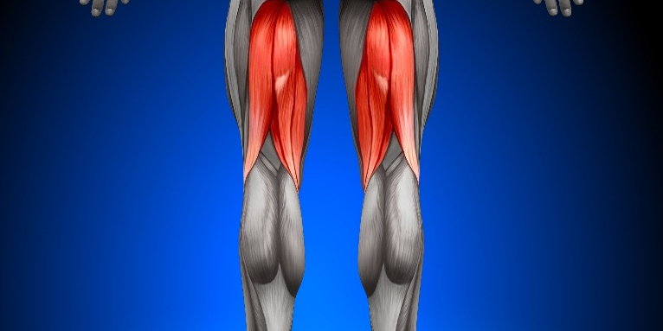Hamstrings: Your hamstrings are made up of four muscles. These are semimembranosus, semitendinosus, and biceps femoris (which consists of a long head and a short head). This muscle is used to flex your knees and extend your hips outwards.

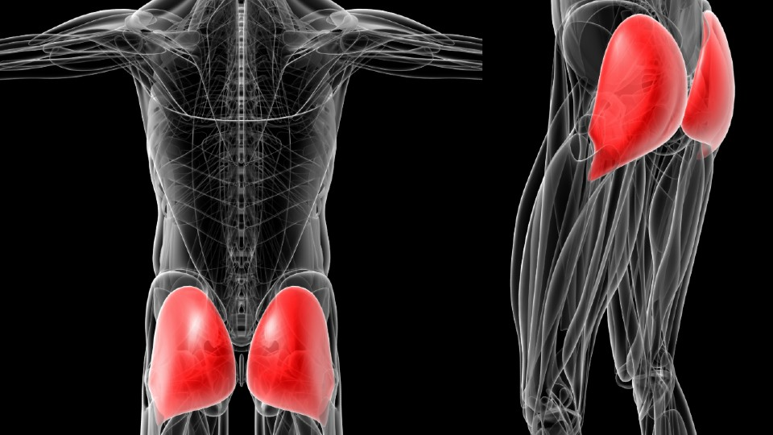Glutes: These are also known as the gluteals (correct name) and are a complex of muscles consisting of the maximus, medius and minimus. The maximus is the largest or the three and trickle down respectively. The maximus allows us to perform exercises such as the hip extension, hip abduction, external rotation and pelvic tilt. The smaller glute medius still occupies a hefty portion of the rear hip musculature and functions primarily as a stabilizer during dynamic movement and as a hip abductor.



Quadriceps: Just like your hamstrings, your “quads” are comprised of four muscles. These muscles (also known as “heads”) are known as the vastus lateralis (“quad sweep”), vastus medialis (“tear drop”), rectus femoris (the middle portion of your upper thigh), and vastus intermedius (which runs underneath the rectus femoris). This muscle is unique in its own but has the main purpose of extending/straightening the knee.

Center Mass

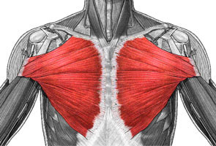Pectorals: There are two major muscles here, the pectoralis major and minor.

The pectoralis major can be divided into two heads: the clavicular head or “upper chest” (which originates at the clavicle) and the sternal head or “lower chest” (which originates at

the sternum). The pecs act to adduct the upper arm (bring the upper arm across the body), and to internally rotate the shoulder joint.

Back: The back is comprised of a massive web of muscles, so just paying attention to the large ones are what will matter.

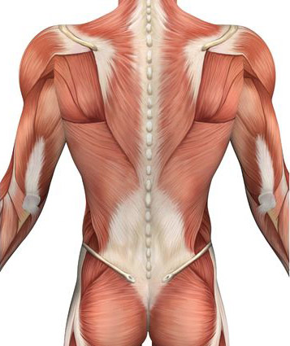The latissimus dorsi (lats for short) is a big muscle which runs from just underneath your arm pit all the way down to the bottom of your back. The lats primarily act to extend the shoulder (bring your upper arm downward) and adduct the shoulder (moving your elbows towards your mid back).

The trapezius (traps for short) is another large muscle running from the base of the skull down to the middle of your inner back.

MisconceptionsMisconceptions

One of the greatest misconceptions about training and going to the gym is *cardio* and its power over fat loss.

When most people think about cardio, they instantly go to something like running or a bike ride. While both are considered cardio, they only fit into the category. Cardio is defined as an aerobic exercise or any form of repetitive body movement over a period which promotes the circulation of oxygen within the blood.

Aerobic – “with oxygen”

Therefore, even while lifting weight, doing it too quickly will result in doing more cardio rather than muscle building.

Now for the part where I tell you about how detrimental cardio can be…

1. Slower Metabolism

This is the process in your body that converts what you eat into energy. Having a slow metabolism just means that your body burns calories slowly. This is where a bit of history comes in too. For our recent ancestry what we wanted in humans was an efficient metabolism, which turns out to be a slow metabolism. We wanted to be able to eat a little amount of food and have that last us a long time. Now we are trying to change that process!

Cardio stresses the body and every time you do it your body gets better at it. This means you become more efficient at cardio, and it starts doing less for you as your body ultimately becomes better at it.

When doing cardio, you are telling your body to become good at doing this activity. Your body then adapts to this stimulus and starts slowing down your metabolism making it more efficient.

When weight loss is your main goal seeing the numbers on the scale go down is a great thing! However, losing those pounds does not mean your body is going to look the way that you want it to.

The composition of fat and muscle in your body can change dramatically depending on what foods you eat and how much of them you eat. In an ideal situation you want to be losing fat while gaining muscle. This would make you look leaner, but it wouldn’t necessarily make the scale go down! This is because muscle weighs more than fat. So, looking leaner does not always mean that the scale is going to move down.

The point of the previous statements is to show that eating more whole foods (watching your diet) while doing resistance training (building muscle) is one of the best stimuli to looking leaner and losing body fat.

This does not mean that you aren’t going to lose weight by doing cardio, but you are just going to be a skinnier version of what you are now. Eventually this will stall too.

Additional Notes

Cardio causes…

Longevity Issues – research has concluded that “On the basis of current knowledge, the goal is to decrease the risk of death and improve life expectancy [with cardio]. Going for a leisurely jog a few times per week at a moderate pace is a good strategy. Higher doses of running are not only unnecessary but may erode some of the remarkable longevity benefits conferred by lower doses of running” (Schnohr 411-419).

Repetitive Stress – Over 35 years the number of people having injuries due to jogging/running has multiplied 20 times. Other forms of cardio are better at reducing stress such as riding your bike or swimming but can still cause issues. The main problem with repetitive stress is coming from people that do not know how to properly run and exercise cardio.

Energy Deficiency – Most times your body cannot simply cope with the stress of running and daily life tasks. Take this from me… I used to run 7 miles in the morning before going to work an 8-hour shift in the Arizona sun. That was possibly one of the worst summers of my life and it took a while for me to adjust to living a normal life, and I still am.

W**ARMING UP**

Before we look at exactly how you should warm-up, it is important to consider what the warm-up portion of your training session serves to accomplish. Warming up should function to increase your core body temperature, which improves performance.

Raising your body temperature is also important, therefore, 5-10 minutes of low to moderate cardio may be needed if you are starting early in the morning or late at night where you need to wake up again.

Secondly, warm-ups serve to increase muscle activation. Doing dynamic warm-ups (exercises and drills which take you through a range of motion) can improve performance and force output.

If available, try using a foam roller before starting a resistance training workout. These have shown to decrease muscle soreness after exercise increasing your range of motion.

Lastly, before starting your exercise (deadlift, bench press etc.) take 1-3 light and easy sets, getting progressively heavier until you reach your “working” weight. This will give you the best range of motion for your coming workout.

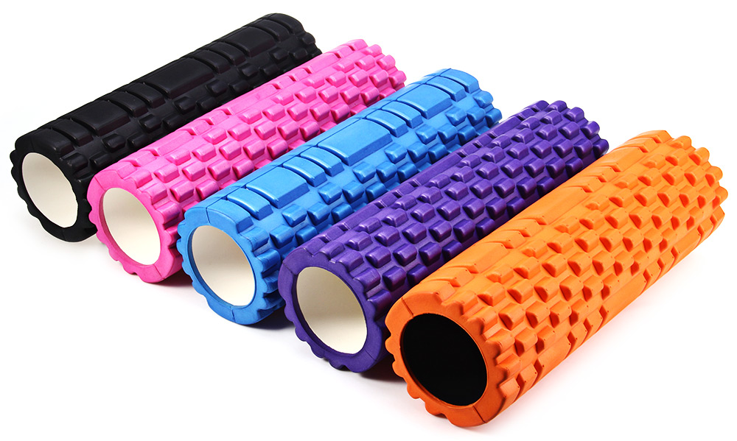

REST AND TRAINING DAYS

Though you may be starting out at the gym and do not have a routine set up, it is important to get one going. Just going to the gym for 15 minutes a day can get you started with some great health benefits.

Having a consistent schedule helps keep you on track and makes sure that you do not end up skipping any exercise sessions!

Example. (My current routine)

|  |  |
| --- | --- |
| Monday | Lower Body #1 |
| Tuesday | Upper Body #1 |
| Wednesday | REST or Light Cardio (no resistance) |
| Thursday | Lower Body #2 |
| Friday | Upper Body #2 |
| Saturday | REST |
| Sunday | REST |

Other routines will follow a similar schedule, however, just make sure that you have at least one day before training the same body part. This means that you do not want to train chest two days in a row.

Just because you are going to the gym four days a week that does not mean you need to do any more or less than you would think. We all have good days and bad ones, we just need to accept that not every day will be the best.

****RPE

This is a term that I use frequently when talking about working out as well as writing down when I am working out. As per the vocabulary page, RPE stands for rate of perceived exertion.

This is a numerical value of how exhausted you are after completing each set of an exercise. Though you can rate this on any scale that you want, I choose to rate my RPE on a scale of 1-10.

On this scale a 1 would mean that the exercise was basically a stretching warmup. I would easily be able to do 20+ more reps of this exercise. I usually skip the 2-5 range because my next warmup is around a 6 which would mean I had a few more reps left but I could see myself getting tired soon.

The best place to keep yourself when working out is going to be an RPE of 8-10 where 8 means you could have done a couple more, a 9 meaning you had maybe 1 rep left but ended safely. A 10 means that you were barely able to get the bar back up or couldn’t alone (BE SAFE).

This brings up something else that should be mentioned before getting into the main program

*RISK vs. REWARD*

Especially when considering your RPE make sure that you do not push yourself too far. In very little circumstances should you be going for an RPE of 10 when alone. Doing this without having someone spotting you could easily end up in an injury.

However, when working with dumbbells that are extended out from your body this wouldn’t be much of an issue. I would recommend that you watch videos explaining how to spot and watching videos on what to do if you happen to fail a squat or bench set.

Pushing yourself far is great but too far may just set you back if you can no longer go to the gym for a couple days or weeks because of injuries.

**SUBSTITUTIONS**

Having access to a gym is great, but not everyone has access to one! This is your chance to try and get some exercise in without the gym!

Some of the greatest workout equipment at the gym are cheap and easy to use. There are only three pieces of equipment that you are going to need!

*Resistance Bands*

**These are affordable and provide endless possibilities of exercise and equipment. The best things about resistance bands is their…**

* **Portability – Pack into your backpack and go to the park!**
* **Versatility – Exercise and work out any part of your body**
* **Variability – Resistance bands come in many different colors which usually dictate the resistance of the band meaning you can move up to different levels**

**Since they are not too expensive I would consider purchasing a set of all different resistances. However, if you can’t try one and see if you need more or less from there (start small and grow).**

**Resistance bands are also great for practicing new exercise forms!**

***Stability Ball***

* **Teaches how to control your balance, which comes from the core.**
* **Encourages strong and well-defined form – important for further compound weight exercises**

***YOUR OWN BODYWEIGHT***

**You can use your body weight in so many applications! Doing push-ups, wall sits and other body weight exercises can accomplish a lot of progress without a gym or $$$!**

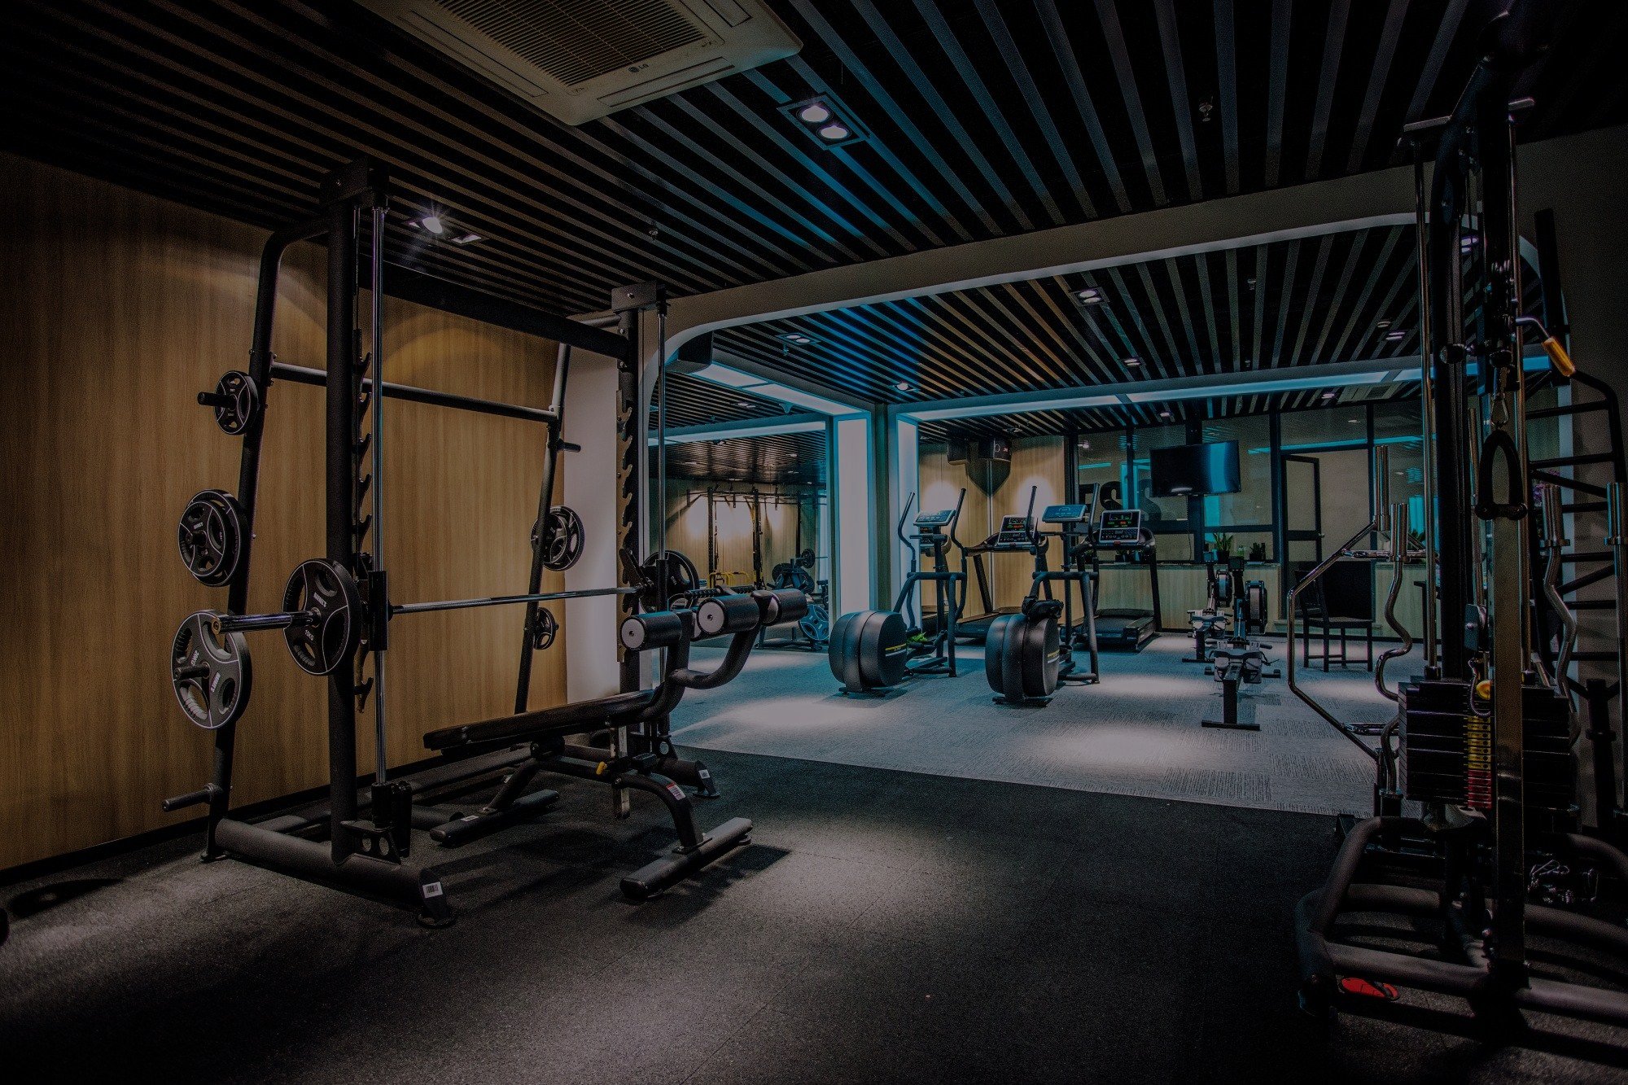

**Beginners Full Body Workout**

**No Weights – At Home**

**9 Weeks**

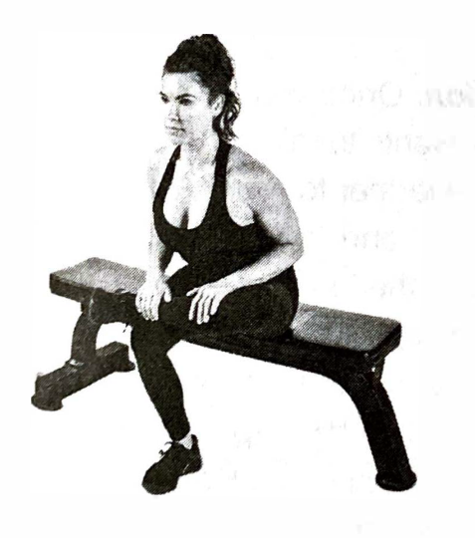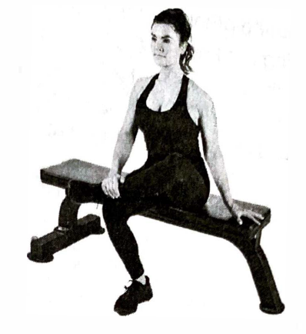**Priming**

The technique of priming is very important in establishing adaption and getting your muscles and body ready for the exercises that are ahead.

Static stretching tells our body to relax the muscle and send a weaker signal to it. Therefore, this creates a relaxed muscle which has less strength and stability which ultimately increases your risk for injury.

This is why we prime our muscles! Doing this allows us to be in the best condition for working out and building strength safely.

The exercises listed on the following pages will be given descriptions that you can come back to here!

Cross-Leg Primer

* Make sure to sit in a chair and keep your knees bent at a right angle. Plant your feet on the ground (no lift).
* Place one foot on top of your knee and sit tall with a straight back
* Lean forward while maintaining your straight back.
* Try to press your crossed foot into the leg that it is resting on and bring the knee of your crossed leg down. * do this without using your hands
* Make sure to hold this position for at least 5-10 seconds

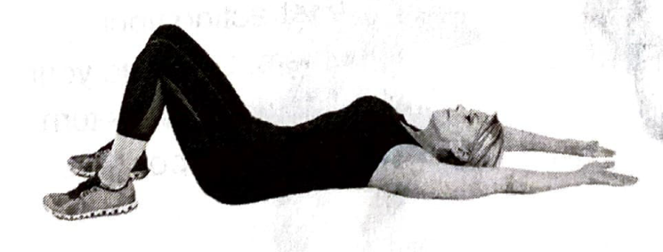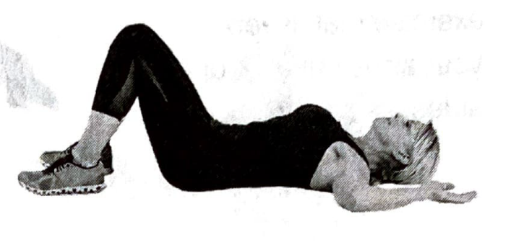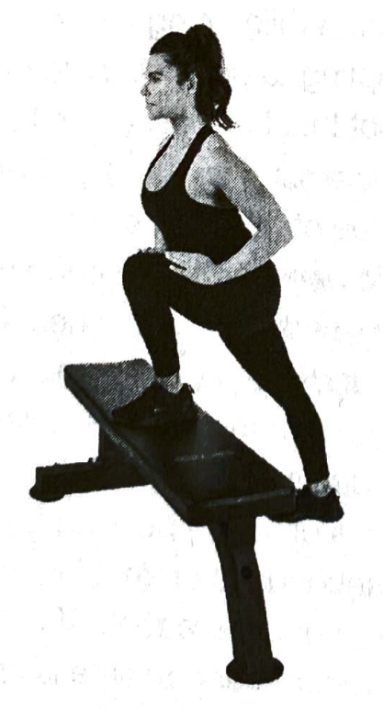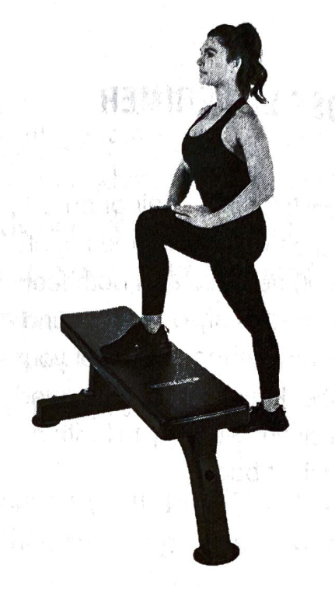

Leg-COMBAT Primer

* Stand in front of a chair or bench
* One foot on the chair and the other foot on the ground
* Bring your knee of the leg on the chair as fat forward without letting your other foot off the ground
* Once far enough, hold the position as long as you can and as far forward as you can without letting the foot upwards.
* You should feel it in your shins

Floor Shoulder Primer

Lay down on your back and bend at your knees

Keep your arms bent, with your elbows, arms and back of your hands touching the floor

Now, reach out and keep going longer and longer keeping contact with the ground.

Imagine you are elastic and stretching your arms out

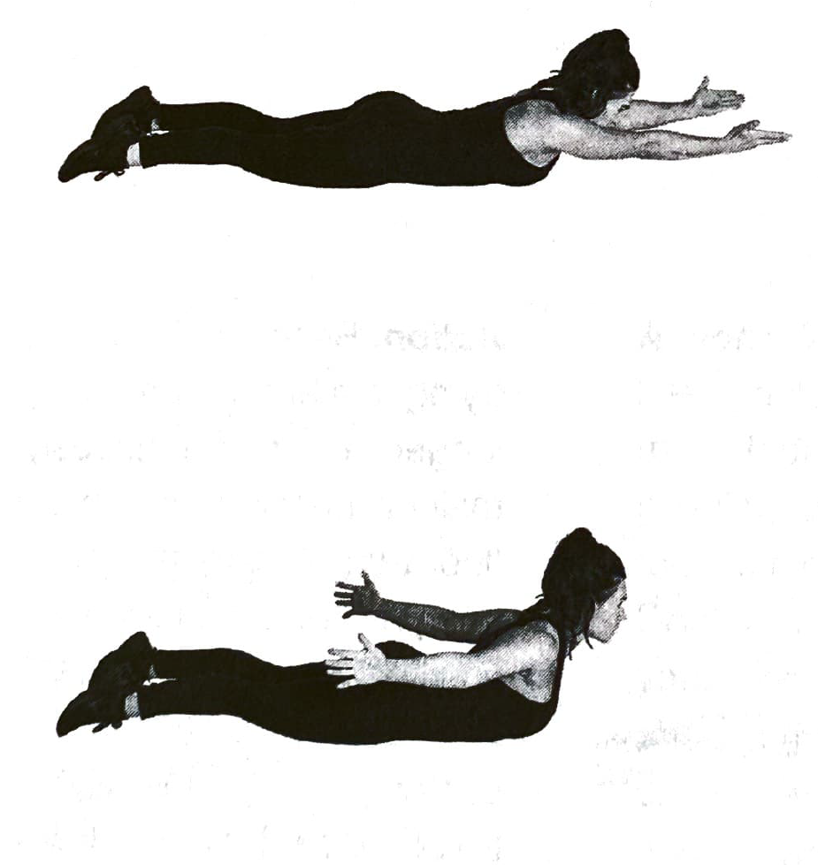

Prone Cobra Primer

* Lay facedown on the floor and keep your arms to your sides
* Lift your arms, chest, and feet off the floor at the same time
* Then pull your arms back and retract your shoulders squeezing your shoulder blades.
* Repeat a few times





go to the gym right now, this might seem like a lot. Just as I have stated previously, going for 15 minutes is just a great start!

Try not to overwhelm yourself! Start with what you think you can handle and eventually it will just start getting easier and you will be on your way to a happier and healthier life.



**Beginners Full Body Weight Workout**

**8 Weeks – Full Equipment**



**Full Body - Week #1 - #3**

**Full Body - Week #4 - #8**





**Beginners Push-Pull 4-Day Split**

**Workout**

**8 Weeks – Full Equipment**



|  |  |  |  |  |
| --- | --- | --- | --- | --- |
| **LOWER BODY #1** | **SETS** | **REPS** | **RPE** | **REST** |
| BACK SQUAT | 3 | 6 | 7 | 3-4MIN |
| ROMANIAN DEADLIFT | 3 | 10 | 7 | 3-4MIN |
| BARBELL HIP THRUST | 3 | 12 | 8 | 2-3MIN |
| LEG EXTENSION | 3 | 12 | 9 | 1-2MIN |
| LYING LEG CURL | 3 | 12 | 9 | 1-2MIN |
| HIP ABDUCTION | 3 | 6 | 7 | 1-2MIN |
| CRUNCH | 3 | 12 | 7 | 1-2MIN |
|  |  |  |  |  |
| **UPPER BODY #1** | **SETS** | **REPS** | **RPE** | **REST** |
| BARBELL BENCH PRESS | 3 | 5 | 7 | 3-4MIN |
| LAT PULLDOWN | 3 | 10 | 8 | 2-3MIN |
| MILITARY PRESS | 3 | 10 | 7 | 3-4MIN |
| CHEST-SUPPORTED ROW | 3 | 12 | 8 | 2-3MIN |
| CABLE FLYE | 3 | 12 | 8 | 1-2MIN |
| DUMBBELL SUPINATED ROW | 3 | 10 | 8 | 1-2MIN |
| ROPE TRICEP EXTENSION | 3 | 12 | 8 | 1-2MIN |
|  |  |  |  |  |
| **LOWER BODY #2** | **SETS** | **REPS** | **RPE** | **REST** |
| DEADLIFT | 3 | 8 | 7 | 3-4MIN |
| WALKING LUNGE | 3 | 10 | 8 | 3-4MIN |
| SINGLE-LEG EXTENSION | 3 | 15 | 8 | 1-2MIN |
| SINGLE-LEG CURL | 3 | 15 | 8 | 1-2MIN |
| HIP ABDUCTION | 3 | 15 | 9 | 1-2MIN |
| CALF RAISE | 3 | 12 | 8 | 1-2MIN |
| PLANK | 3 | 20SEC | 8 | 1-2MIN |
|  |  |  |  |  |
| **UPPER BODY #2** | **SETS** | **REPS** | **RPE** | **REST** |
| INCLINE PRESS | 3 | 8 | 8 | 3-4MIN |
| REVERSE GRIP PULLDOWN | 3 | 8 | 8 | 2-3MIN |
| ASSISTED DIP | 3 | 10 | 7 | 1-2MIN |
| BAR BENT OVER ROW | 3 | 12 | 7 | 2-3MIN |
| DUMBBELL LATERAL RAISE | 3 | 15 | 8 | 1-2MIN |
| FACE PULL | 3 | 15 | 8 | 1-2MIN |
| HAMMER CURL | 3 | 8 | 9 | 1-2MIN |

**Lower & Upper Body - Weeks 1-4**

**Lower & Upper Body – Weeks 5-8**

|  |  |  |  |  |
| --- | --- | --- | --- | --- |
| **LOWER BODY #1** | **SETS** | **REPS** | **RPE** | **REST** |
| DEADLIFT | 3 | 5 | 8 | 3-4MIN |
| GOBLET SQUAT | 3 | 12 | 8 | 3-4MIN |
| HIP THRUST | 3 | 10 | 9 | 2-3MIN |
| LEG PRESS | 3 | 12 | 8 | 2-3MIN |
| LYING LEG CURL | 3 | 15 | 9 | 1-2MIN |
| STANDING CALF RAISE | 3 | 8 | 8 | 1-2MIN |
| BICYCLE CRUNCH | 3 | 12 | 8 | 1-2MIN |
|  |  |  |  |  |
| **UPPER BODY #1** | **SETS** | **REPS** | **RPE** | **REST** |
| BARBELL BENCH PRESS | 3 | 8 | 8 | 3-4MIN |
| SINGLE ARM PULLDOWN | 3 | 8 | 8 | 2-3MIN |
| DB SEATED SHOULDER PRESS | 3 | 12 | 7 | 2-3MIN |
| DUMBBELL ROW | 3 | 12 | 8 | 2-3MIN |
| ASSISTED DIPS | 3 | 6 | 8 | 1-2MIN |
| SEATED FACE PULL | 3 | 15 | 9 | 1-2MIN |
| EZ BAR CURL | 3 | 12 | 9 | 1-2MIN |
|  |  |  |  |  |
| **LOWER BODY #2** | **SETS** | **REPS** | **RPE** | **REST** |
| BACK SQUAT | 3 | 8 | 8 | 3-4MIN |
| HIP THRUST | 3 | 8 | 8 | 3-4MIN |
| ROMANIAN DEADLIFT | 3 | 12 | 8 | 1-2MIN |
| SEATED LEG CURL | 3 | 8 | 9 | 1-2MIN |
| STANDING CALF RAISE | 3 | 6 | 9 | 1-2MIN |
| HANGING LEG RAISE | 3 | 6 | 8 | 1-2MIN |
| HIP ABDUCTION | 3 | 20 | 9 | 1-2MIN |
|  |  |  |  |  |
| **UPPER BODY #2** | **SETS** | **REPS** | **RPE** | **REST** |
| MILITARY OVERHEAD PRESS | 3 | 6 | 8 | 3-4MIN |
| NEUTRAL-GRIP PULLDOWN | 3 | 6 | 8 | 2-3MIN |
| DB INCLINE PRESS | 3 | 8 | 8 | 1-2MIN |
| CABLE SEATED ROW | 3 | 8 | 9 | 2-3MIN |
| CABLE LATERAL RAISE | 3 | 12 | 8 | 1-2MIN |
| REVERSE PEC DECK | 3 | 12 | 8 | 1-2MIN |
| SINGLE ARM CABLE CURL | 3 | 15 | 9 | 1-2MIN |





**5 Day Body Part Split**

**Full Weight - 8 Week Program**

**5 Day Body Part Split Weeks 1 - 4**

|  |  |  |  |  |
| --- | --- | --- | --- | --- |
| **CHEST & TRICEPS** | **SETS** | **REPS** | **RPE** | **REST** |
| BARBELL BENCH PRESS | 3 | 6 | 7 | 3-4MIN |
| DB INCLINE PRESS | 3 | 8 | 8 | 2-3MIN |
| CABLE FLYE | 3 | 12 | 8 | 1-2MIN |
| ASSISTED DIPS | 3 | 10 | 7 | 1-2MIN |
| SKULL CRUSHERS | 3 | 12 | 8 | 1-2MIN |
|  |  |  |  |  |
| **LEGS & ABS** | **SETS** | **REPS** | **RPE** | **REST** |
| BACK SQUAT | 3 | 6 | 7 | 3-4MIN |
| ROMANIAN DEADLIFT | 3 | 8 | 7 | 2-3MIN |
| BARBELL HIP THRUST | 3 | 12 | 8 | 2-3MIN |
| LEG EXTENSION | 3 | 12 | 8 | 1-2MIN |
| LEG CURL | 3 | 12 | 8 | 1-2MIN |
| CALF RAISE | 3 | 8 | 7 | 1-2MIN |
| CRUNCH | 3 | 12 | 7 | 1-2MIN |
|  |  |  |  |  |
| **BACK & BICEPS** | **SETS** | **REPS** | **RPE** | **REST** |
| REVERSE LAT PULLDOWN | 3 | 8 | 8 | 2-3MIN |
| CABLE SEATED ROW | 3 | 10 | 8 | 2-3MIN |
| CHEST SUPPORTED ROW | 3 | 12 | 8 | 2-3MIN |
| SEATED FACE PULL | 3 | 15 | 8 | 1-2MIN |
| DB SUPINATED CURL | 3 | 12 | 8 | 1-2MIN |
|  |  |  |  |  |
| **LEGS & ABS** | **SETS** | **REPS** | **RPE** | **REST** |
| DEADLIFT | 3 | 5 | 7 | 3-4MIN |
| WALKING LUNGE | 3 | 10 | 8 | 2-3MIN |
| SINGLE LEG EXTENSION | 3 | 15 | 8 | 1-2MIN |
| SINGLE LEG CURL | 3 | 15 | 8 | 1-2MIN |
| HIP ABDUCTION | 3 | 15 | 7 | 1-2MIN |
| STANDING CALF RAISES | 3 | 12 | 8 | 1-2MIN |
| PLANK | 3 | 20sec | 8 | 1-2MIN |
|  |  |  |  |  |
| **SHOULDERS & ARMS** | **SETS** | **REPS** | **RPE** | **REST** |
| MILITARY PRESS | 3 | 6 | 7 | 3-4MIN |
| DB LATERAL RAISE | 3 | 12 | 8 | 1-2MIN |
| CABLE REVERSE FLYE | 3 | 15 | 8 | 1-2MIN |
| ROPE TRICEP EXTENSION | 3 | 12 | 8 | 1-2MIN |
| SINGLE ARM CABLE CURL | 3 | 12 | 8 | 1-2MIN |

**5 Day Body Part Split Weeks 5 - 8**

|  |  |  |  |  |
| --- | --- | --- | --- | --- |
| **CHEST & TRICEPS** | **SETS** | **REPS** | **RPE** | **REST** |
| BARBELL BENCH PRESS | 3 | 8 | 8 | 3-4MIN |
| MACHINE INCLINE PRESS | 3 | 12 | 8 | 2-3MIN |
| PEC DECK | 3 | 12 | 8 | 1-2MIN |
| ASSISTED DIPS | 3 | 6 | 8 | 1-2MIN |
| CABLE TRICEPS KICKBACK | 3 | 15 | 8 | 1-2MIN |
|  |  |  |  |  |
| **LEGS & ABS** | **SETS** | **REPS** | **RPE** | **REST** |
| DEADLIFT | 3 | 5 | 8 | 3-4MIN |
| GOBLET SQUAT | 3 | 12 | 8 | 2-3MIN |
| HIP THRUST | 3 | 10 | 9 | 2-3MIN |
| LEG PRESS | 3 | 12 | 8 | 1-2MIN |
| LYING LEG CURL | 3 | 15 | 9 | 1-2MIN |
| CALF RAISE | 3 | 8 | 8 | 1-2MIN |
| BICYCLE CRUNCH | 3 | 12 | 8 | 1-2MIN |
|  |  |  |  |  |
| **BACK & BICEPS** | **SETS** | **REPS** | **RPE** | **REST** |
| LAT PULLDOWN | 3 | 6 | 8 | 2-3MIN |
| DUMBBELL ROW | 3 | 12 | 8 | 2-3MIN |
| BAR BENT OVER ROW | 3 | 12 | 8 | 2-3MIN |
| REVERSE PEC DECK | 3 | 15 | 8 | 1-2MIN |
| BAR CURLS | 3 | 15 | 8 | 1-2MIN |
|  |  |  |  |  |
| **LEGS & ABS** | **SETS** | **REPS** | **RPE** | **REST** |
| BACK SQUATS | 3 | 8 | 8 | 3-4MIN |
| HIP THRUST | 3 | 8 | 8 | 2-3MIN |
| ROMANIAN DEADLIFTS | 3 | 12 | 8 | 2-3MIN |
| LEG CURLS | 3 | 8 | 9 | 1-2MIN |
| CALF RAISES | 3 | 6 | 9 | 1-2MIN |
| LEG RAISE | 3 | 6 | 8 | 1-2MIN |
| HIP ABDUCTION | 3 | 20 | 9 | 1-2MIN |
|  |  |  |  |  |
| **SHOULDERS & ARMS** | **SETS** | **REPS** | **RPE** | **REST** |
| DB SEATED SHOULDER PRESS | 3 | 10 | 7 | 3-4MIN |
| CABLE LATERAL RAISE | 3 | 10 | 8 | 1-2MIN |
| DB BENT OVER LATERAL RAISE | 3 | 12 | 8 | 1-2MIN |
| DUMBBELL FLOOR PRESS | 3 | 15 | 8 | 1-2MIN |
| HAMMER CURL | 3 | 8 | 8 | 1-2MIN |



**Diet and Nutrition**



Redefine How You Eat

One of the greatest issues we have in the 21st century with eating is not necessarily what we eat, but rather how much we eat. Though processed foods are a leading reason to why we overeat (sugar craves more sugar), having too much of anything is a reason to gain weight.

I am a firm believer in the theory that calories in = calories out. This means that what energy we put into our body (known as calories) must be expended throughout the day. If we eat more calories than we expend, we gain weight and the opposite if we don’t have enough to eat.

There is more science to these thoughts once we take in macronutrient concentration within our diet, but this is a great start.

The usual United States diet consists of a large amount of carbohydrates and neglects both protein and some fats. These end up being the three main macronutrients (out of four), fats, carbs and protein. When going to the gym, protein ends up being the most important in gaining muscle. The essential amino acids within proteins allow us to rebuild the tissue that is broken down when we do resistance training.

**The end goal with your eating habits is to reach what is called intuitive eating. You eventually want to be able to live your day without tracking what you eat while being able to control how much you eat and the portions that you consume. I believe it is important to track calories when starting out. This is so you can really see how much you are eating. What you think looks like a cup of rice might be a bit more or a lot more and can easily add up to almost 200+ more calories per meal. Tracking your calories allows you to one day be able to look at something like a chicken breast and see that it looks close to 4-5oz.**

**I had been tracking my calories for almost one full year before I was able to understand the food that was around me and how to control my portions. Some people are able to get around this sooner and some people take more time.**

**There are many diet plans floating around the world right now that can easily sway you towards one way or another. When I tracked my calories that is mostly what I focused on, not carbs or fat. I gave myself a protein goal, then the rest was filled in by carbs and fat.**

**The usual protein goal and what I would suggest for anyone is 1 gram of protein for each pound of body weight. I weigh 155lbs right now and try to consume at least 155g of protein per day.**

Intuitive Eating

Stay Consistent

One great benefit of resistance training is once you start regularly working out you are going to want to eat more healthy food! Proven by a Stanford study, researchers found that people are more likely to naturally eat more nutritious foods once they start to exercise. Why would you want to just throw away all the hard work that you did at the gym with a bad diet?!

**Awareness**

This comes back to what I said about tracking your calories when you begin working through a diet. By tracking your calories to begin with you will be more aware of the portion sizes around you and will be better able to judge in the future.

**Avoid Heavily Processed Foods**

This is one rule I would suggest that everyone follow. Some of the worst diets in the world are those that involve a large amount of heavily processed foods. Heavily processed foods are shown to have an average increase of about 500 calories per day and also cause you to eat the meals quicker!

Lots of money in science and research has been put into these processed meals to make us want to eat them as quick as we can because they are SO good. And when we are done with them, we are not full so we order more. This is a large challenge to get rid of these foods, however, doing it is futile in living a healthier life.

Intuitive Eating

Trying to Lose weight?

* Stop trying to do too many things at once while you are eating. Make the meal the main part of what you’re doing. It is really easy to eat a whole bag of chips when you’re watching television and unaware.
* Have a set location where you eat your meals that isn’t at your desk or in bed. Eat at some place that becomes sacred to the action of eating.
* Eat slower and chew your food all the way through. You can get more satisfaction from less food if it tends to stay in your mouth.
* The one thing that has helped me a lot was not drinking while you are eating! This is great because drinking usually washes everything down and you are less able to gauge how full you are.
* Put down your fork/spoon in between bites of food.

These are some great tips that I have used to eat less during my meals!

**Foodie Emotions**

Learn to make peace with the food that you eat. Sometimes you are really going to want that processed piece of food. You are going to be at a party with a bunch of friends and there is going to be a lot of pizza or cake. For your mental and emotional health it is okay to eat these things. Every once in a while you need to enjoy these things or else you can go down bad paths into binge eating or other disorders.

Understand your Food – Food is what supports building muscle and keeping your body healthy. Not eating enough food will cause you to lose muscle, strength and cognitive abilities. Losing weight is great but not eating enough to support your lifestyle can be detrimental.

Go Slowly! To stay in shape and enjoy your life you must understand that things will come slowly. Trying to do things too quickly will cause you to backfire and most likely go back to where you were before. Steady and slow changes are easier to keep long term. Determine your pace and find what you can stick with to be happy the rest of your life.

Things will always be changing and you will get better and better at finding new meals and intuitive eating. Eventually, eating healthy and maintaining a healthy body will be a natural process and just another extension of who you are!

Fats

Though protein is very important so are your fats!

Having around 40-70 grams of fat throughout your day is the minimum requirement and some people feel great. However, other people may need some more fat within their diet to feel good. Personally I have to eat closer to the 70 grams to feel good. Doing this just means that I have to lower the amount of carbs I eat during the day to compensate for the increase in fat intake.

Some of the best things to eat which add fat into your diet include avocado, butter, oils (coconut, EVOO*), fish oil, ghee and some nuts. The fats that you are going to want to avoid are the processed ones that you would find in most fast food dining and refined oils. Examples of this include vegetable oils and things with large amounts of trans fats.

Carbs

Fats are good for regulating emotions and protein is good for building muscle, so what are carbs good for?

Carbs are great for your energy levels! This is what gives you that boost of energy and helps with prolonged activity throughout your day. The most simple carbohydrate is sugar which can be found in multiple forms. These include fructose, sucrose and lactose. Simple carbs are digested quickly and are great for a small short burst of energy. These can be great during a workout if you are starting to feel a bit tired.

*Think back to the last time you had a candy bar or a box of fruit punch. That quick happy and fuzzy sensation you get right after eating is the sugar being digested! This is what I mean by quick digesting carb.*

Starches are going to be your more complex cabohydrates which will last you the whole dsay. These are found naturally in most vegetables. The most notable of which are potatoes, these have a low calorie dense and satisfying taste that will give you lasting energy throughout the day. Potatoes are awesome!

I would usually fill what I eat in the day with fats and protein, then the rest are carbs!





PROTEIN

All macronutrients are important on their own, however, one of the most important when considering resistance training is PROTIEN!

Protein is one of the three essential macronutrients (fat, carbs, and protein) and is built up of building blocks called amino acids. You may have heard of these before and protein is actually built up of about 20 amino acids. Not all protein sources contain all amino acids, for example, many plant proteins lack them while animal proteins are more complete.

What makes protein important is how it constructs material for muscle growth and being broken down through exercise. Protein aids with tissue, organs, hormones and enzymes. This is what makes muscle building possible!

I would recommend that everyone eat 1 gram of protein per pound of bodyweight! So if you weigh 155lbs then you should try and eat about 155 grams of protein per day. Although something around 0.8 grams should work, but I prefer to have more because it makes me feel better throughout the day.

Animal Proteins

* Chicken (white and dark meat)
* Cottage cheese
* Eggs and egg white
* Greek Yogurt
* Beef, Pork
* Fish (Salmon, cod etc..)
* Turkey

Plant Proteins

* Legumes
* Nuts
* Beans

Don’t neglect your fats! These are important too! It’s good to cook with some oil or to have some fatty fish!

Diet and Nutrition Summary

1. Drink More Water! Rather than having sugar filled beverages which usually supply empty calories. Opt for some more water. You will feel great!
2. Eat more unprocessed foods! Go for cleaner and more whole food options over those processed boxed, canned or pre-packaged meals
3. Eat foods that contain not only clean ingredients but a small amount of ingredients. If you read the back of a label and there are 10+ ingredients, there are most likely some processed items
4. Use good oils when cooking! Extra Virgin Olive Oil and expeller pressed avocado/coconut oils are a great start
5. Avoid food additives and preservatives. These are usually pretty easy to tell apart because these are going to be the packages that have 10+ ingredients
6. Try new foods! New cuisine and trying new things will keep you on track and mentally capable of not going off on bad foods
7. Do NOT be afraid of FATS. This was something I was horrible with for too long and it caused me a lot of issues in the end.
8. Don’t be afraid of sodium either! Unless you are told by someone (doctor not your dog) that you need to limit sodium, then eat up
9. Make simple and small changes to your meals! Keep trying new things and keep yourself wanting more good foods
10. My last and final tip is to have fun and enjoy life. Eating good foods and taking care of your body is going to last you the rest of your life. If you want a happier life for the rest of your life, this is the best place to start!